**PRACTICAL 03**

SSH Server : Password Authentication

Configure SSH server to manage a server from the remote computer, SSH Client :

(Ubuntu and Windows)

SETUP SSH SERVER: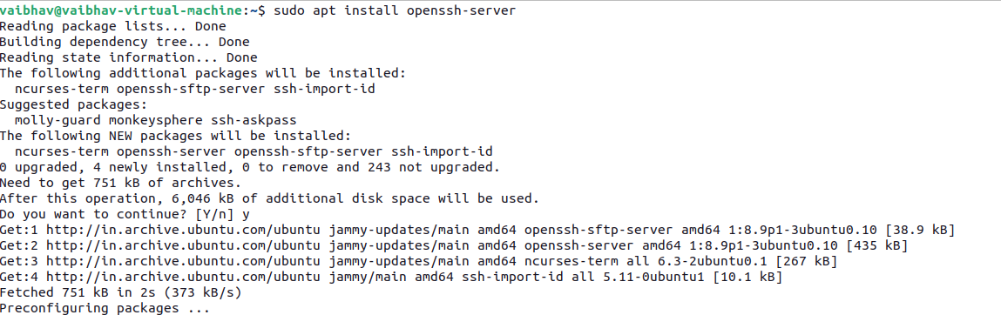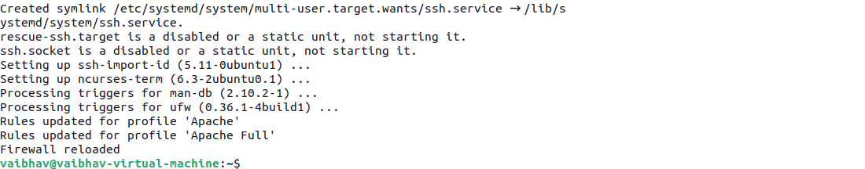

Start and enable the SSH service

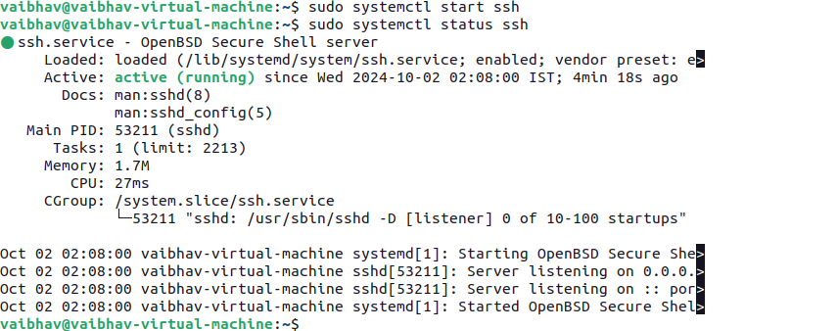

Configure SSH settings (optional but recommended)



**Change the default port (optional)**: Change the default SSH port (22) to reduce the risk of automated attacks.

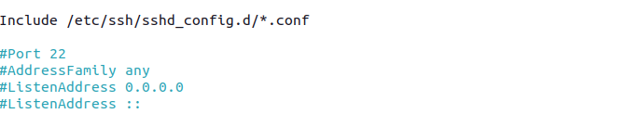

**Disable root login**: Disallow logging in as the root user for security purposes.



After making changes, restart the SSH service and **Enable firewall** if not already done:



Set up firewall rules (if applicable)



Test the SSH connection

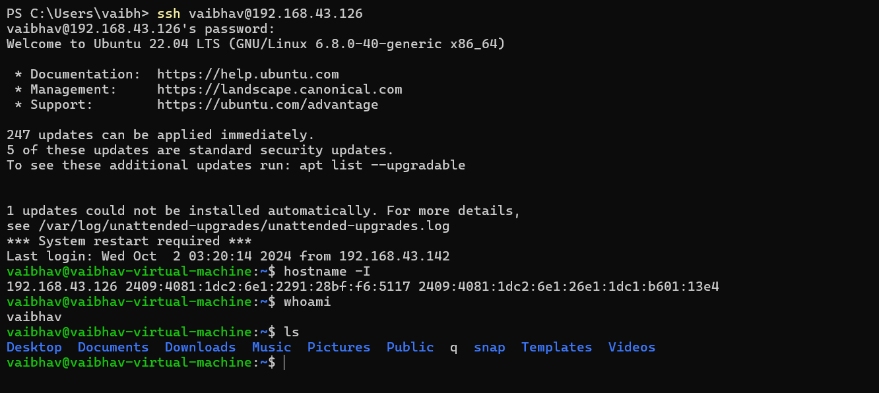

Disable password authentication



On your local machine (the client), generate an SSH key pair for passwordless and secure login.

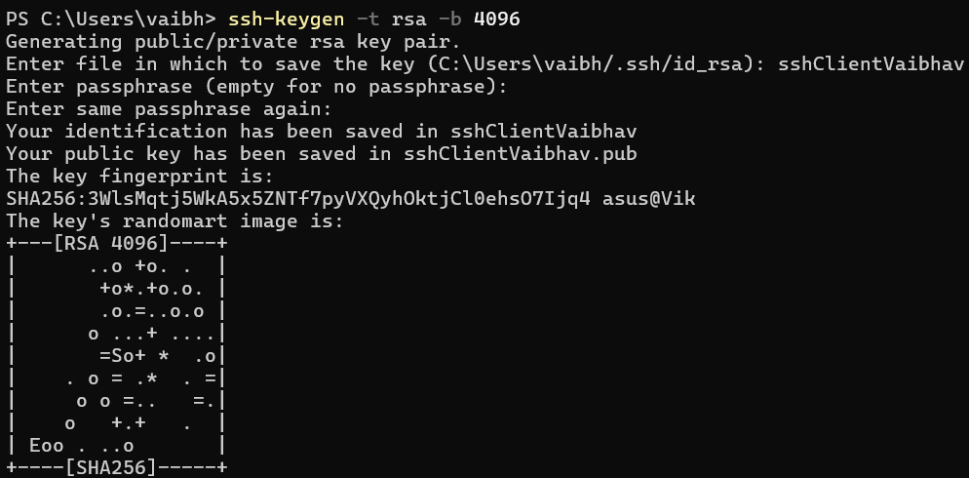



Verify that the correct private key is being used on your Windows machine.

